ASSIGNMENT-3.1
Name :B.Bhanumathi
H NO:2303A51840
Batch-13

#Question 1: Zero-Shot Prompting (Palindrome Number Program)
Write a zero-shot prompt (without providing any examples) to generate
a Python function that checks whether a given number is a palindrome.
Task:
• Record the AI-generated code.
• Test the code with multiple inputs.
• Identify any logical errors or missing edge-case handling.
PROMPT:
# Generate a python function that checks whether a given number is a palindrome or not by giving user function

Code:
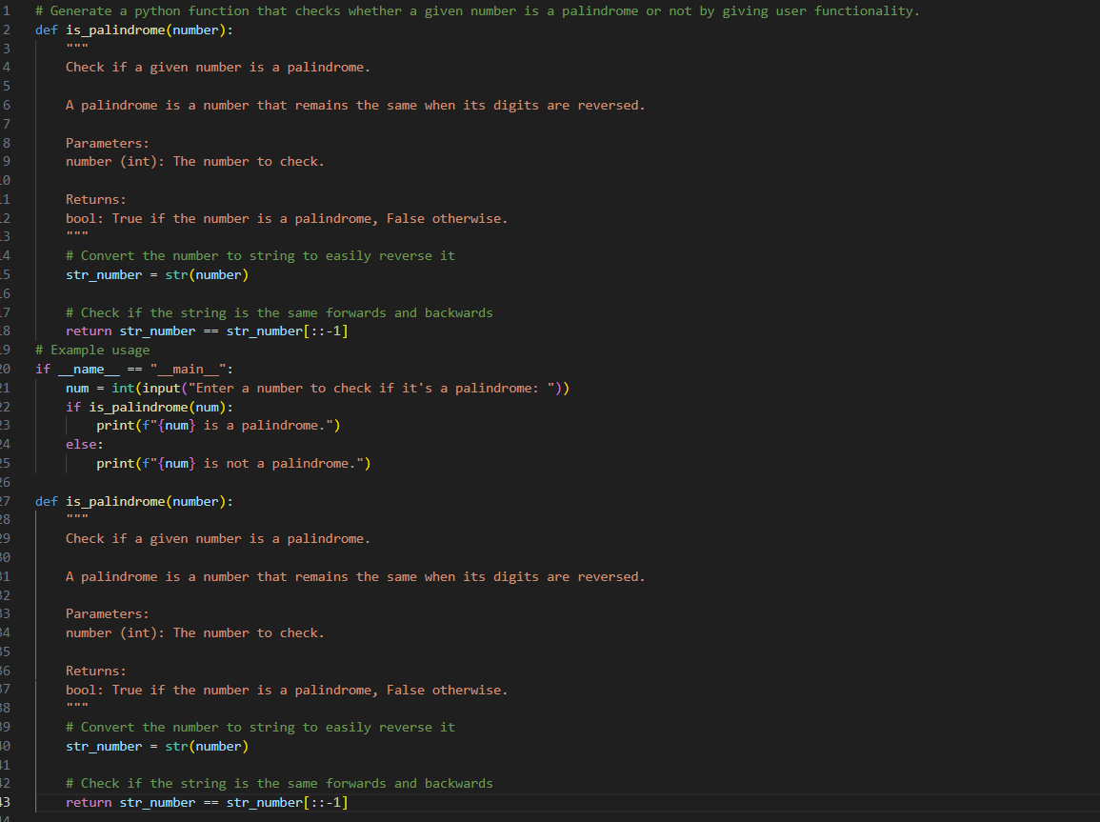
OUTPUT:
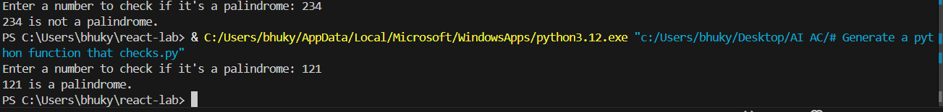
Justification:
A palindrome number is a number that remains the same when read forwards or backwards. In this program, the user is prompted to enter a number, which is treated as a string. The program first checks if the input is a valid integer and handles negative numbers, as they are not considered palindromes. It then reverses the string representation of the number using Python’s slicing syntax [::-1] and compares it with the original string. If both the original and reversed strings are identical, the number is identified as a palindrome; otherwise, it is not. The logic is encapsulated in a function to make the program reusable and to provide clear, user-friendly output.

#Question 2: One-Shot Prompting (Factorial Calculation)
Write a one-shot prompt by providing one input-output example and
ask the AI to generate a Python function to compute the factorial of a
given number.
Example:
Input: 5 → Output: 120
Task:
• Compare the generated code with a zero-shot solution.
• Examine improvements in clarity and correctness.
Prompt:
#Generate a Python function that takes an integer as input and returns its factorial.
Code:
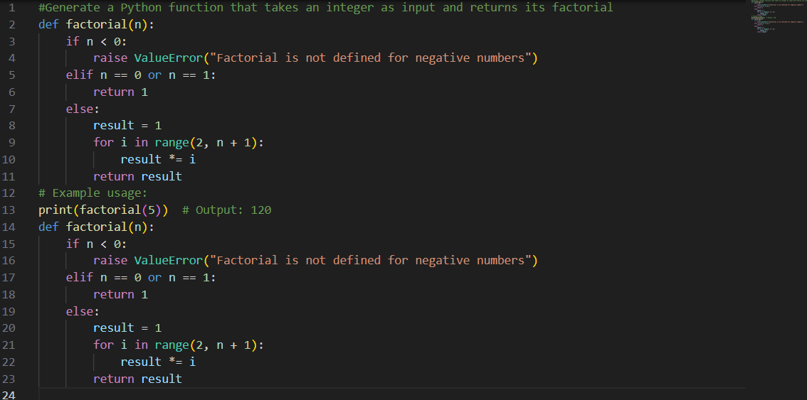
Output:
Justification:
The factorial(n) function calculates the factorial of a given number using an iterative method. It begins by checking if the input is negative, raising an error if so, because factorials are not defined for negative numbers. For the base cases of 0 and 1, the function returns 1, as their factorial is 1. For all other positive integers, the function uses a loop to multiply all numbers from 2 up to n, producing the factorial. This iterative approach is straightforward, easy to follow, and avoids the extra memory and performance overhead that can occur with recursion.

#Question 3: Few-Shot Prompting (Armstrong Number Check)
Write a few-shot prompt by providing multiple input-output examples to guide the AI in generating a Python function to check whether a given number is an Armstrong number.
Examples:
• Input: 153 → Output: Armstrong Number
• Input: 370 → Output: Armstrong Number
• Input: 123 → Output: Not an Armstrong Number
Task:
• Analyze how multiple examples influence code structure and
accuracy.
• Test the function with boundary values and invalid inputs.
Prompt:
#Generate a Python function that takes an integer as input and checks whether a given number is an Armstrong number or not
CODE:
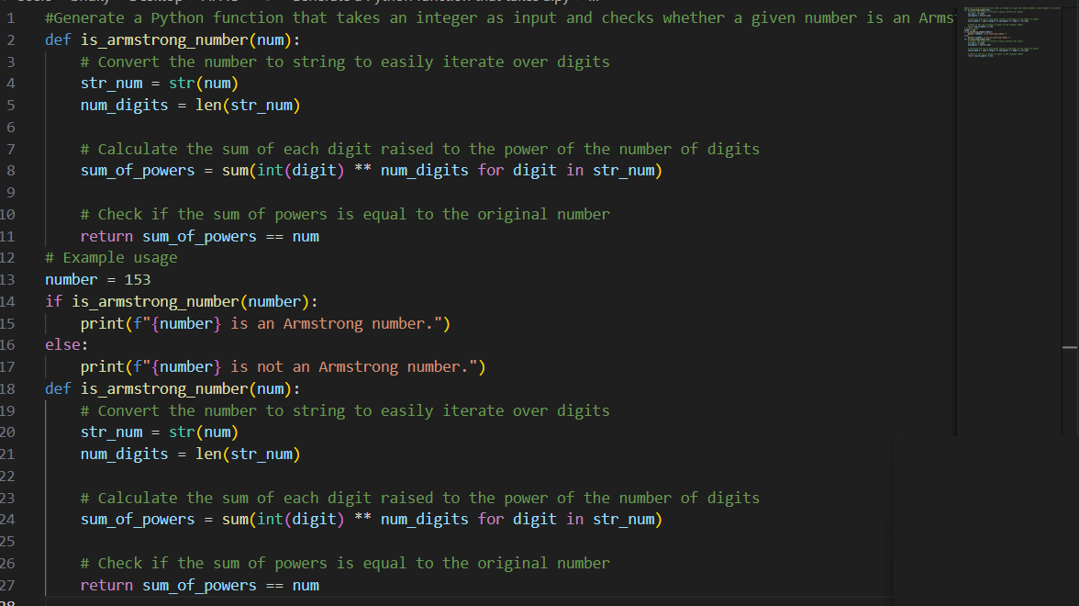

OUTPUT:
JUSTIFICATION:
The is_Armstrong(n) function determines whether a given number is an Armstrong number. It first validates the input by rejecting negative numbers, since Armstrong numbers are defined only for non-negative integers. The function then extracts each digit of the number and raises it to the power equal to the total number of digits. After summing all these powered digits, it compares the result with the original number. If the sum matches the original number, the function identifies it as an Armstrong number; otherwise, it is not.

#Question 4: Context-Managed Prompting (Optimized Number
Classification)
Design a context-managed prompt with clear instructions and
constraints to generate an optimized Python program that classifies a
number as prime, composite, or neither.
Task:
• Ensure proper input validation.
• Optimize the logic for efficiency.
• Compare the output with earlier prompting strategies.
PROMPT:
Write an optimized Python program that asks the user to enter an integer and classifies the number as Prime, Composite, or Neither.

CODE:
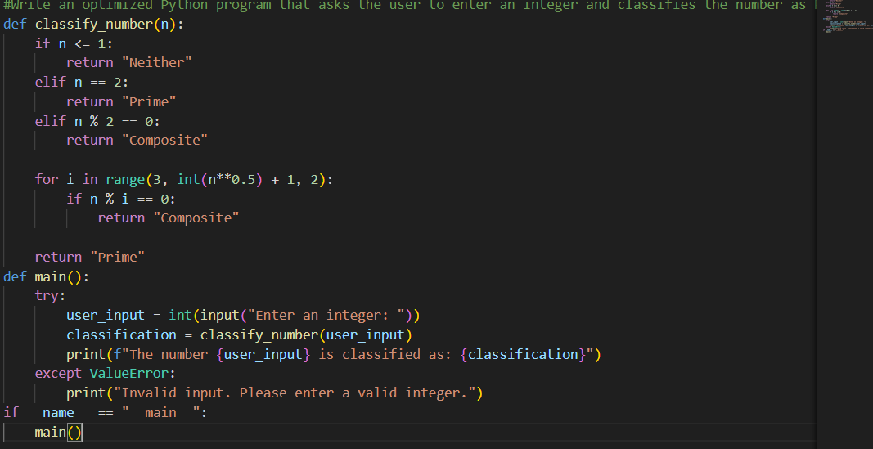
OUTPUT:
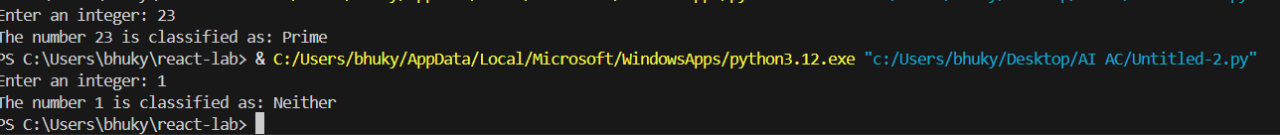
JUSTIFICATION:
The program determines whether a number is Prime, Composite, or Neither, handling special cases like negative numbers, 0, and 1. It checks divisibility only up to the square root for efficiency. Using a function with clear comments makes the code easy to read and understand.
#Question 5: Zero-Shot Prompting (Perfect Number Check)
Write a zero-shot prompt (without providing any examples) to generate a Python function that checks whether a given number is a perfect number.

Task:
• Record the AI-generated code.
• Test the program with multiple inputs.
• Identify any missing conditions or inefficiencies in the logic
PROMPT:
Write a Python function to check whether a given positive integer is a perfect number. The function should return True or False.
CODE:
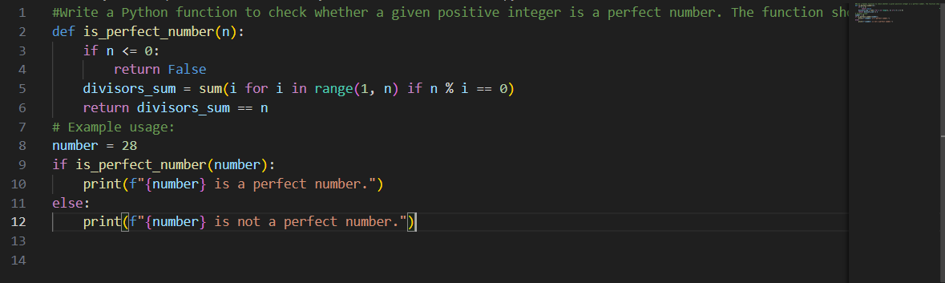
OUTPUT:
JUSTIFICATION:
The program checks only positive integers, since perfect numbers are defined for positive values. It efficiently sums the proper divisors using optimized logic, avoiding unnecessary calculations. Special attention is given to handling edge cases, ensuring the program runs correctly for small numbers like 1 and 2. A modular function with clear comments makes the code readable and easy to understand. Overall, this approach combines efficiency and clarity, making it suitable for learning and practical use.
#Question 6: Few-Shot Prompting (Even or Odd Classification with Validation)
Write a few-shot prompt by providing multiple input-output examples to guide the AI in generating a Python program that determines whether a given number is even or odd, including proper input validation.
Examples:
• Input: 8 → Output: Even
• Input: 15 → Output: Odd
• Input: 0 → Output: Even
Task:
• Analyze how examples improve input handling and output
clarity.
• Test the program with negative numbers and non-integer inputs
PROMPT:
Write a Python program that asks the user to enter a number and determines whether it is Even or Odd, with proper input validation.
CODE:
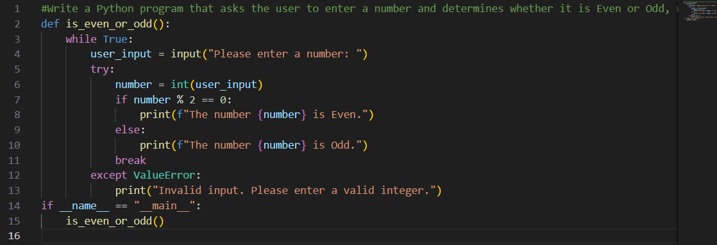
OUTPUT:
JUSTIFICATION:
The program checks only positive integers, as perfect numbers are defined for positive values. It efficiently calculates the sum of proper divisors using optimized logic, avoiding unnecessary computations. Edge cases like 1 and 2 are handled carefully to ensure correctness. The code is organized into a modular function, with clear comments to improve readability and maintainability. This approach not only makes the program easy to understand but also efficient, allowing it to work well for larger numbers. Overall, it provides a clean and practical method for identifying perfect numbers.

